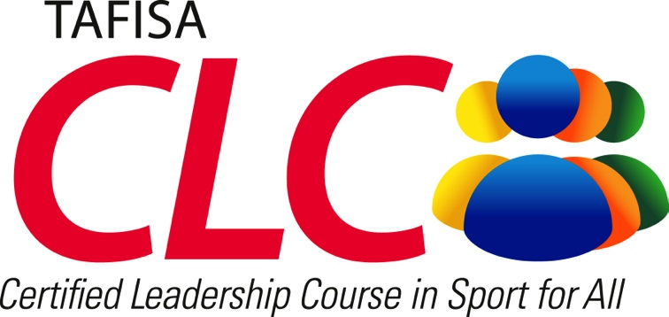
MARFIMA

4th to 10th May 2014, Kuala Lumpur, Malaysia

REGISTRATION FORM

Please complete and return this form and copies of international passport(s) by Friday 4th April 2014 to:

TAFISA Office, Attn: Bae Schilling
Email: info@tafisa.net
Fax: +49 (0) 69 97 39 35 99 25
Post: Mainzer Landstraße 153, Dienstleistungszentrum
D-60261 Frankfurt am Main, Germany

Organisation:
Contact Name:
Address:
Country:
Phone: |  | +
Fax: |  | +
E-mail:
Website:
 | O | Yes! I/We am/are interested in participating!
 | Expected number of participants:
 | Name(s) of participants:
 | I/We need a formal letter of invitation for visa purposes: |  |  |  |  | O Yes O No
Other Comments:
Signature: |  |  |  | Date:

